**Lesson08 Azure App Service CROS**

**Notes: -**

**1-by default CROS origin is disabled which means when you have 2 app service like web application that hit to web API app service it will not allowed**

**2-CORS (cross-origin resource sharing):- this is method of restrict access to resources on web page when its requested from another domain outside the domain from which the initial resource is being served**

**(you have to enabled It on the Web API)**

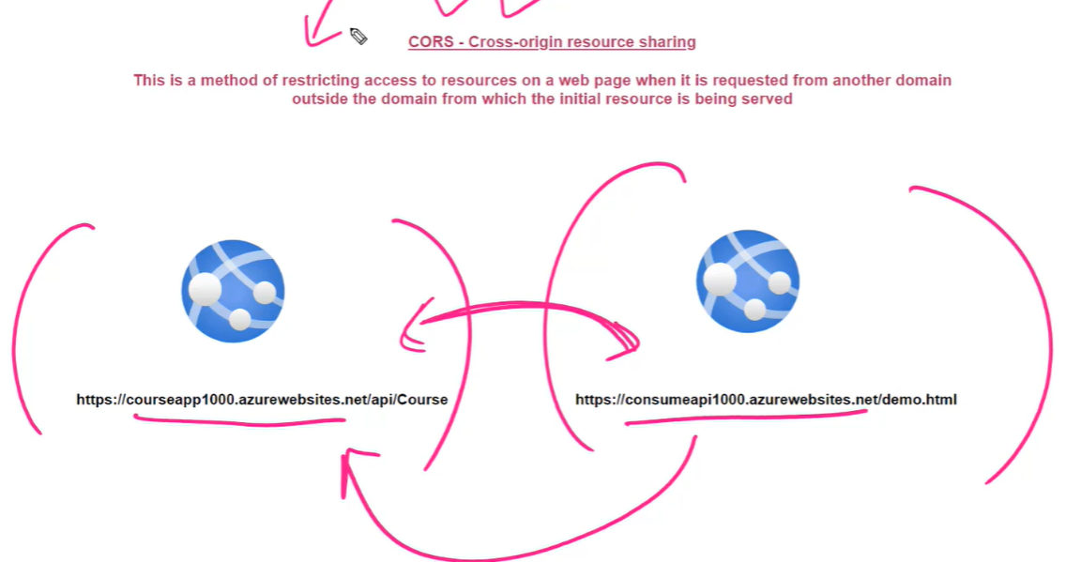

**Steps:-**

**1-on Azure portal > create app service called web-api-service**

**2-we create another app service called app-sample-service**

**3-on the web app we update the url**

**<html>**

**<head>**

**<title> Calling the API</title>**

**<script src="https://ajax.googleapis.com/ajax/libs/jquery/3.3.1/jquery.min.js"></script>**

**<script>**

**$(document).ready(function() {**

**$.ajax({**

**//this is the url of the web API app service**

**url: "https://web-api-service.azurewebsites.net/api/Course",**

**type: "Get",**

**success: function(result) {**

**console.log(result);},**

**error: function(error){**

**console.log(error);}})})**

**</script>**

**</head>**

**<body></body></html>**

**4-on web API > publish > we publish web api on the web-api-service**

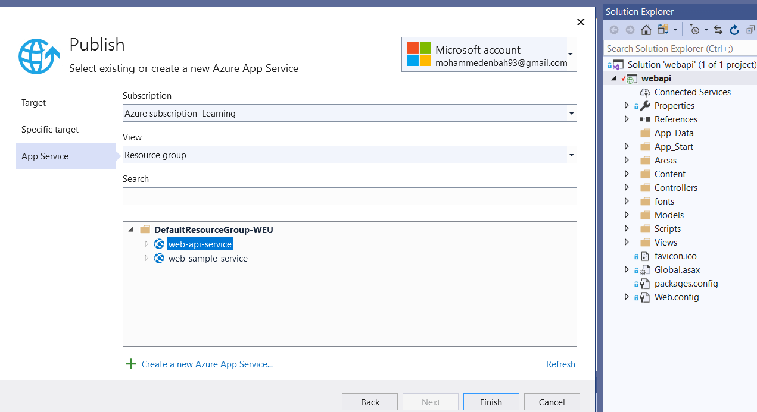

**5-on consumeAPI> publish > we publish web api on the app-sample-service**

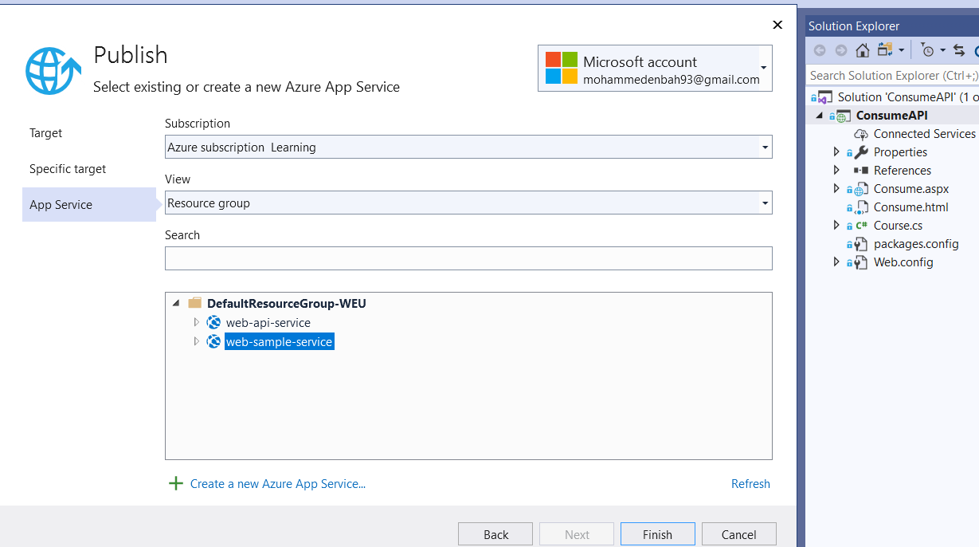

**6-on the Web API app service type the folllowing url**

[**https://web-api-service.azurewebsites.net/api/Course**](https://web-api-service.azurewebsites.net/api/Course)

**7-on the web app type the following url (it will show inner exception CROS)**

[**https://web-sample-service.azurewebsites.net/consume.html**](https://web-sample-service.azurewebsites.net/consume.html)

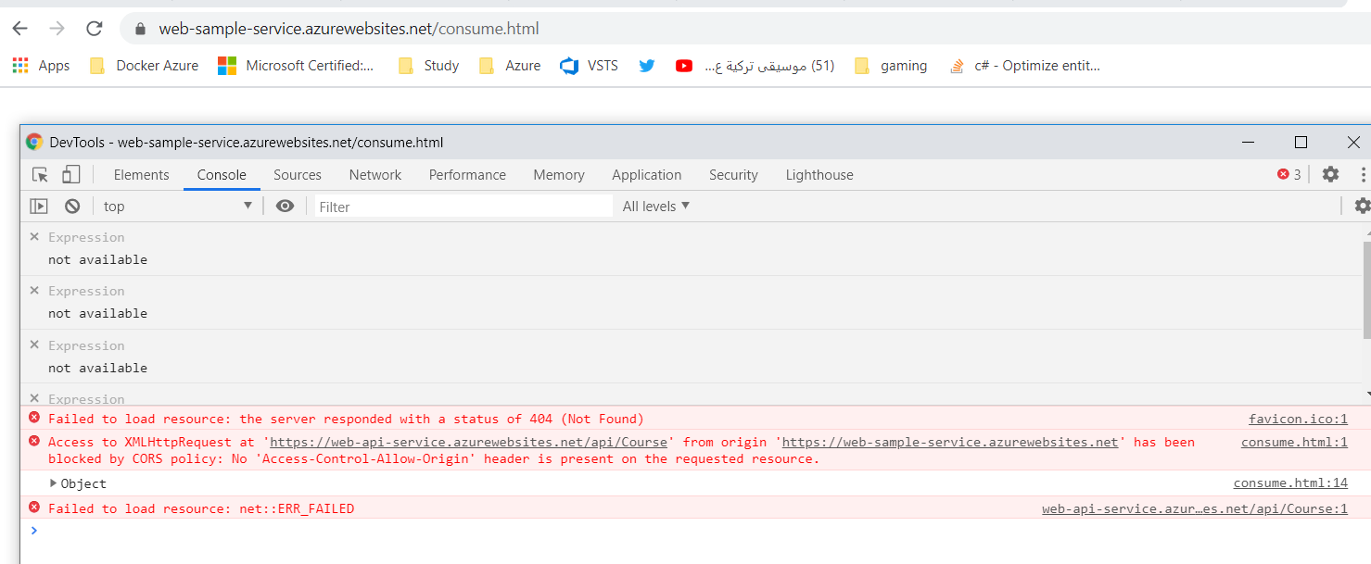

8-on the web-api app servcie

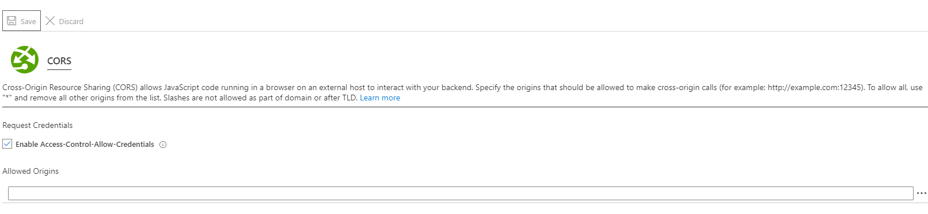

**9-on the web app we see the issue is solved by enabled CROS origin**

